COAL LAB #08

Task#1:

Program 1:
org 100h
MOV AL, 11100000b
SHL AL, 1
RET

Output:
AL | 11000000b

CF | 1

Program 2:
org 100h
MOV AL, 00000111b
SHR AL, 1
RET

Output:
AL | 00000011b

CF | 1

Task# 2:

Solution:
mov al, 0d4h
shr al, 1;
AL = 6Ah
mov al, 0d4h
sar al, 1;
AL = EAh
mov al, 0d4h
sar al, 4;
AL = FDh
mov al, 0d4h
shl al, 1;
AL = A8h

Task# 3:

Answer:
The ROL (Rotate Left) instruction:
- Shifts all bits to the left.
- The highest bit (MSB) is copied to both the Carry Flag (CF) and the lowest bit position (LSB).

Task# 4:

Code:
org 100h
MOV AL, [byte1];
SHL AL, 2;
MOV [byte1], AL;
MOV AL, [byte2];
SHL AL, 2;
MOV [byte2], AL;
MOV AL, [byte3];
SHL AL, 2;
MOV [byte3], AL;
RET

Output:
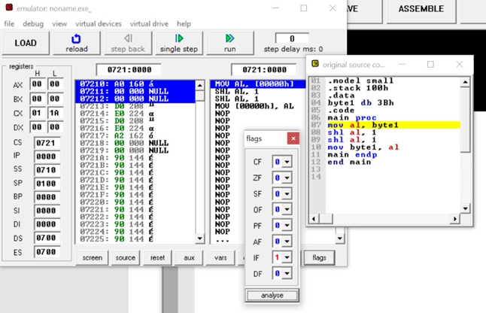
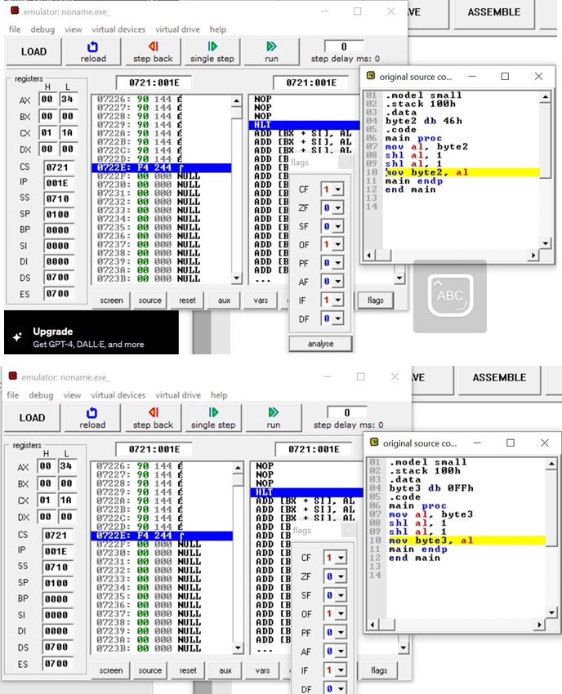

Task# 5:

Answer:
The ROR (Rotate Right) instruction:
- Shifts all bits to the right.
- The lowest bit (LSB) is copied to the Carry Flag (CF).
- The Carry Flag is copied to the highest bit position (MSB).

Task# 6:

Code:
org 100h
MOV AL, 5;
MOV CL, 3;
SHL AL, CL;
MOV [result], AL ;
RET
operand db 5;
n db 3;
result db ?

